

TECHNICAL SPECIFICATION

|  |  |
| --- | --- |
| TITLE | WebServices Documentation |
| VERSION | 0.1 |
| AUTHOR | Rafael Diel |
| DATE | 7.7.2012 |

Change Log

|  |  |  |  |
| --- | --- | --- | --- |
| Version | Date | Changed By | Changes Description |
| 0.1 | 13.06.2012 | Rafael Diel | Initial version |
| 0.2 | 06.07.2012 | Rafael Diel | Included two new webservices:   * CheckUserArticle * NewArticlePurchase   Updated two webservices with output “ArticleId”:   * GetHints * GetQuestion |

Table of Contents

1 Introduction 5

1.1 Document Objective 5

2 WebServices 6

2.1 GetNews 6

2.1.1 Description 6

2.1.2 Inputs 6

2.1.3 Outputs 6

2.1.4 Path 6

2.1.5 Sample 7

2.2 GetHints 8

2.2.1 Description 8

2.2.2 Inputs 8

2.2.3 Outputs 8

2.2.4 Path 8

2.2.5 Sample 9

2.3 GetQuestion 10

2.3.1 Description 10

2.3.2 Inputs 10

2.3.3 Outputs 10

2.3.4 Path 10

2.3.5 Sample 11

2.4 GetAffiliates 12

2.4.1 Description 12

2.4.2 Inputs 12

2.4.3 Outputs 12

2.4.4 Path 12

2.4.5 Sample 13

2.5 GetUserInfo 14

2.5.1 Description 14

2.5.2 Inputs 14

2.5.3 Outputs 14

2.5.4 Path 14

2.5.5 Sample 15

2.6 NewUser 16

2.6.1 Description 16

2.6.2 Inputs 16

2.6.3 Outputs 16

2.6.4 Path 16

2.6.5 Sample 17

2.7 UpdateUserInfo 18

2.7.1 Description 18

2.7.2 Inputs 18

2.7.3 Outputs 18

2.7.4 Path 18

2.7.5 Sample 19

2.8 CheckUserArticle 20

2.8.1 Description 20

2.8.2 Inputs 20

2.8.3 Outputs 20

2.8.4 Path 20

2.8.5 Sample 21

2.9 NewArticlePurchase 22

2.9.1 Description 22

2.9.2 Inputs 22

2.9.3 Outputs 22

2.9.4 Path 22

2.9.5 Sample 23

# Introduction

## Document Objective

This document contains the technical specification for the required WebServices in order to allow the development of and iPad & iPhone Poker Application.

These WebServices can be updated during the development phase, according with the application needs.

All the WebServices are based in PHP and JSON.

# WebServices

## GetNews==Done

### Description

The GetNews webservice should be used in order to retrieve the News list from the MySQL database, and display them in the “NEWS” tab in the application. Only the ACTIVE news will be retrieved in this webservice.

### Inputs

The GetNews webservice has no inputs.

### Outputs

The GetNews webservice will return the following info:

* NewsTitle
* NewsLink
* NewsDate
* NewsImage
* NewsSource

### Path

http://www.acexgames.com.br/app_ws/GetNews.php

### Sample

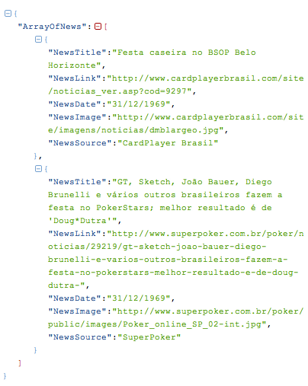

## GetHints==Done

### Description

The GetHints webservice should be used in order to retrieve the daily Hint from the MySQL database, and display them in the “HINT OF THE DAY” (DICA DO DIA) tab in the application. Also, the MORE INFO details for that HINT will also will be retrieved and can be 1 to “n”, and will be displayed in the application as a list. Only HINTs with “MORE INFO” information available in the database will be retrieved in this webservice, randomly.

### Inputs

The GetHints webservice has no inputs.

### Outputs

The GetHints webservice will return the following info:

Hint:

* HintText

More Info:

* ArticleId
* MoreTitle
* MoreLink

### Path

http://www.acexgames.com.br/app_ws/GetHints.php

### Sample

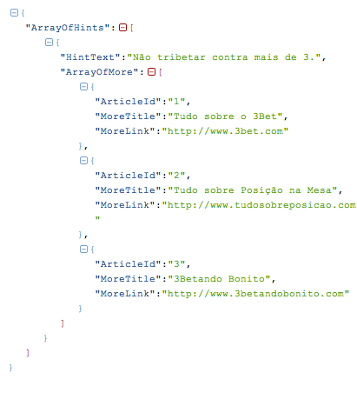

## GetQuestion

### Description

The GetQuestion webservice should be used in order to retrieve the daily Question from the MySQL database, and display them in the “ASK THE PRO” (Pergunte ao PRO) tab in the application. Also, the MORE INFO details for that QUESTION will also will be retrieved and can be 1 to “n”, and will be displayed in the application as a list. Only QUESTIONs with “MORE INFO” information available in the database will be retrieved in this webservice, randomly.

### Inputs

The GetQuestion webservice has no inputs.

### Outputs

The GetQuestion webservice will return the following info:

Question:

* QuestionDate
* QuestionText
* QuestionAnswer

More Info:

* ArticleId
* MoreTitle
* MoreLink

### Path

http://www.acexgames.com.br/app_ws/GetQuestion.php

### Sample

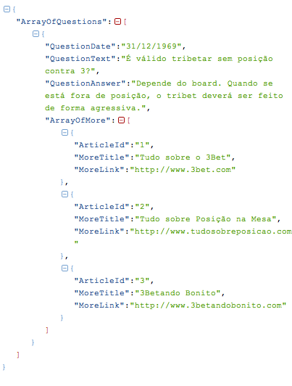

## GetAffiliates==Done

### Description

The GetAffiliates webservice should be used in order to retrieve the Affiliates list from the MySQL database, and display them in the “AFFILIATES” tab in the application.

### Inputs

The GetAffiliates webservice has no inputs.

### Outputs

The GetAffiliates webservice will return the following info:

* AffTitle
* AffLink
* AffImage

### Path

http://www.acexgames.com.br/app_ws/GetAffiliates.php

### Sample

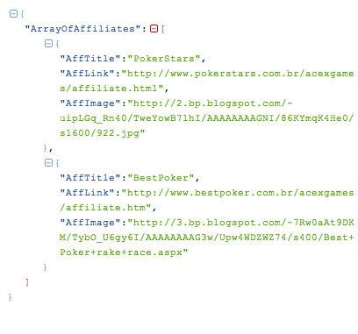

## GetUserInfo==Done

### Description

The GetUserInfo webservice should be used in order to retrieve the user data from the MySQL database, given an email, and display them in the “CONFIG” tab in the application.

### Inputs

The GetUserInfo webservice has the following inputs:

* email

### Outputs

The GetUserInfo webservice will return the following info:

* UserEmail
* UserPasswd
* UserBirthDt
* UserAskSubsc
* UserHintSubsc

### Path

http://www.acexgames.com.br/app_ws/GetUserInfo.php?email=mail@rdiel.com

### Sample

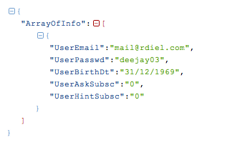

## NewUser==Done

### Description

The NewUser webservice should be used in order to create a new user in the MySQL database, and register this new user in the application. This action should be handled in the “CONFIG” tab.

### Inputs

The NewUser webservice has the following inputs:

* email
* pwd
* birth

### Outputs

The NewUser webservice will return the following messages, according with the information provided:

* Required field not sent
* Email already being used
* Success

This information will be returned in the ReturnMessage tag.

### Path

http://www.acexgames.com.br/app_ws/NewUser.php?email=mail@rdiel5.com&pwd=teste_senha_123&birth=1978-06-08

### Sample

Success:

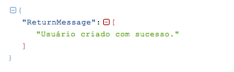

Required field not sent:

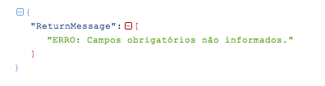

Email already being used:

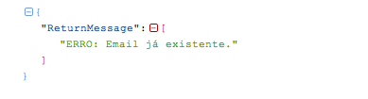

## UpdateUserInfo==Done

### Description

The UpdateUserInfo webservice should be used in order to update the user information in the MySQL database. This action should be handled in the “CONFIG” tab.

### Inputs

The UpdateUserInfo webservice has the following inputs:

* email
* pwd
* birth

### Outputs

The UpdateUserInfo webservice will return the following messages, according with the information provided:

* Required field not sent
* Email not found
* Success

This information will be returned in the ReturnMessage tag.

### Path

http://www.acexgames.com.br/app_ws/UpdateUserInfo.php?email=mail@rdiel5.com&pwd=teste_senha_123&birth=1978-06-08

### Sample

Success:

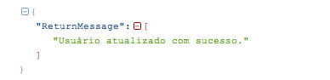

Required field not sent:



Email not found:

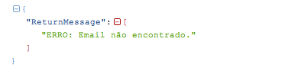

## CheckUserArticle

### Description

The CheckUserArticle webservice should be used in order to verify if the user, in the MySQL database, already purchased the specified article. This webservice will be invoked ebery time a user tries to open an article.

### Inputs

The CheckUserArticle webservice has the following inputs:

* email
* article

### Outputs

The CheckUserArticle webservice will return the following info:

* UserId
* ArticleId
* Purchased

### Path

http://www.acexgames.com.br/app_ws/CheckUserArticle.php?email=mail@rdiel.com&article=5

### Sample

Article Already Purchased:

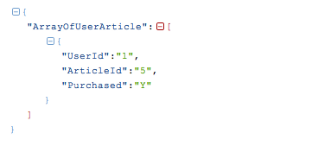

Article Not Purchased:

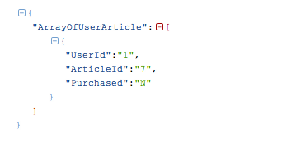

## NewArticlePurchase

### Description

The NewArticlePurchase webservice should be used in order to update the MySQL database with the articles purchased by a given user. This action should be handled after the user confirms a purchase in iTunes popup.

### Inputs

The NewArticlePurchase webservice has the following inputs:

* email
* article

### Outputs

The NewArticlePurchase webservice will return the following messages, according with the information provided:

* Required field not sent
* Success

This information will be returned in the ReturnMessage tag.

### Path

http://www.acexgames.com.br/app_ws/NewArticlePurchase.php?email=mail@rdiel.com&article=3

### Sample

Success:

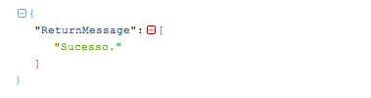

Required field not sent:

